

A PROJECT REPORT

Submitted by

ROOPAM JAIN

In partial fulfillment for the award of the degree

Of

BACHELOR OF TECHNOLOGY

In

COMPUTER SCIENCE & ENGINEERING

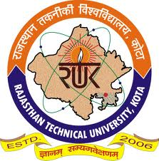

May 2012

DEPARTMENT OF INFORMATION TECHNOLOGY
RAJASTHAN TECHNICAL UNIVERSITY
KOTA, RAJASTHAN

A
Major Project Report
Submitted
In partial fulfillment
For the award of the Degree of

BACHELOR OF TECHNOLOGY

In Department of Computer Science

Submitted By: Guided By: Submitted To:
Roopam Jain Manmohan Sharma Bhupendra Singh Rao


May 2012

Department of Computer Science & Engineering
Techno India NJR Institute of Technology, Udaipur

Rajasthan Technical University

CERTIFICATE

This is to Certified that this project report “Get2gether” is the confide work of “ROOPAM JAIN” who carried out the project work under my supervision. I approve this project for submission of the Bachelor of Technology in the Department of Computer Science and Engineering, Techno India NJR Institute of Technology, Udaipur, affiliated to Rajasthan Technical University- Kota.

MR. MANMOHAN SHARMA MR. BHUPENDRA SINGH RAO

Assistant Professor & Head Project In charge

Department of Computer Science Department of Computer Science
Techno India Njr Institute of Technology Techno India NJR Institute of Technology
Udaipur Udaipur

